Read the Chapter 5 Mini Case on pages 236-237 in Financial Management: Theory and Practice. Using complete sentences and academic vocabulary, please answer questions a through f.
Create a 5-10 slide PowerPoint presentation in which you summarize your answers from the mini case. Be sure to include graphs, charts, and trends as appropriate.

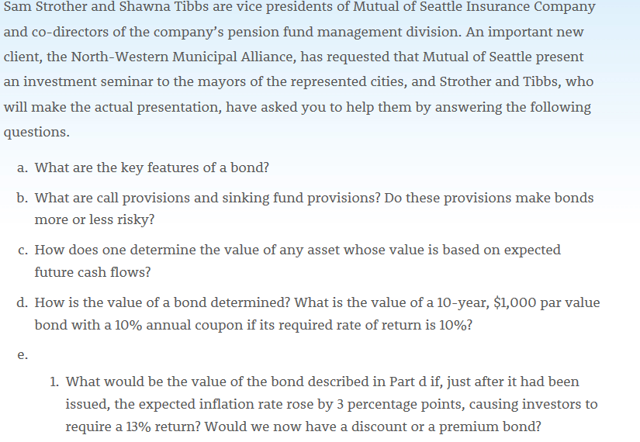
- Face value: amount one gets back from the issuer on maturity of the bond
Maturity: the time bound when the bond comes due.
Coupon: periodic redeeming of the interest value of the bond.
- A call provision gives the issuing corporation the right to call the bonds for redemption. The call provision generally states that the company must pay the bondholders an amount greater than the par value if they are called. The sinking fund provision facilitates the orderly retirement of the bond issue. On rare occasions the firm may be required to deposit money with a trustee, which invests the funds and then uses the accumulated sum to retire the bonds when they mature. The call provision bonds are valuable to the firm but not with the investor if at the time of the bond issuance, the interest rates are high. This can be considered a risky provision while the sinking fund provision bonds are considered less risky than the ones without a provision. When sinking funds are issued, they have lower levels of coupon rates than other bonds out of the sinking funds category.
- Cash flow method can be used to determine the value of an asset when there are a series of expecting future cash flows. The information needed for the cash flow method includes the asset’s required rate of return, the time period for the expected cash flows, the interest payment frequency, and the future value of the asset. Each cash flow is then discounted back to current period using the required rate of return as the discount rate. The asset’s value is the sum of the present value of each cash flow.
- A bond value is calculated based on the bond’s required rate of return, the bond’s coupon rate, the frequency of the coupon payments, and the maturity date of the bond. The value of a bond is determined by discounting the expected future cash flows using the bond's required rate of return. The required rate of return for a bond can be determined by summing of risk-free rate, the bond’s default risk premium, liquidity premium and maturity risk premium. By using the required rate of return as discount rate, each bond coupon payment is discounted to current period. The bond’s value is the sum of discounted interest payments plus the discounted par value of the bond.
Bond value = $C_{r}* F_{v}*\frac{1-{\left(1+R\right)}^{-t}}{R}+\frac{F_{v}}{{\left(1+r\right)}^{t}}$
Whereby:
C_{r} = coupon rate
F_{v} = face value
R = Interest Rate
T = time
$0.10*1000*\frac{1-{\left(1+0.10\right)}^{-10}}{0.10}+\frac{100}{{\left(1+0.10\right)}^{10}}$

$0.10*1000*\frac{0.6145}{0.10}+\frac{1000}{2.5937}$
$=0.10*1000*6.145+385.55$
$=61.45+385.55$
= 447.00
- 1. The value of the described bond (with the inflation rising 3 percentage points) would now be: 837.213. This would now be a discount bond.
2. The value of the bond would increase to 1210.71. This bond would now be a premium bond.
3. If it remained at 13%: The closer the bond reaches the maturity date, the more discounted it becomes. If it remained at 7%: The closer the bond reaches the maturity date, the more the premium increases.
- Using present value interest factors:
$887.00 = $90(PVIFAk,10) + $1,000(PVIFk,10)
Where k is the bond's YTM. The best way to solve for k = YTM is to use a financial calculator with a bond valuation capability. Input the following into your financial calculator: N=10, PV=-887.0, PMT=90, FV=1,000, and then solve for I = k = YTM = 10.91%. Because the YTM is greater than bond’s coupon rate, this bond is selling at a discount.
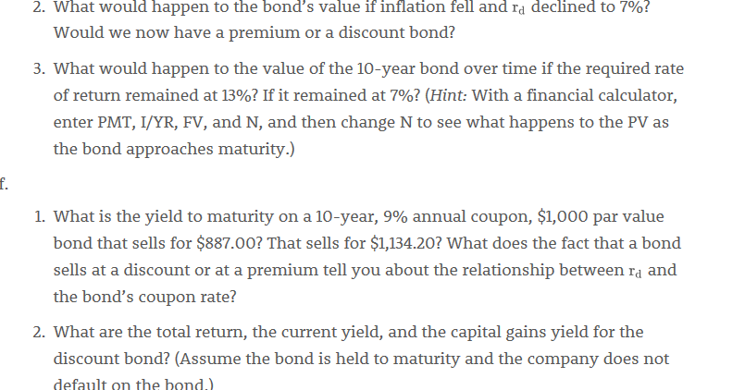
2.

